Matthew Kuriakose Baker
Bible Doctrine III
March 21, 2006
Creation Example

Example from creation that shows the creator.

The Human Eye:
The outer part of the eye is composed of three layers of tissue.
Outside layer is the sclera, a protective coating.
Middle layer is the choroids, a vascular layer
Innermost layer is the retina, light-sensitive.

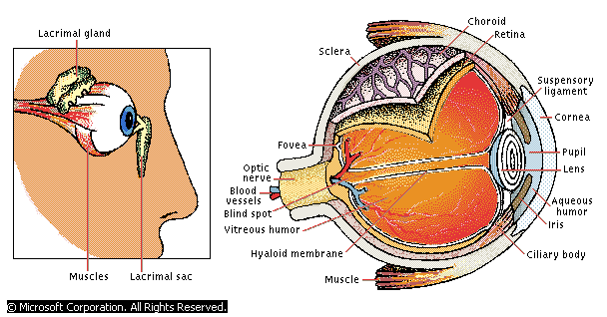

Illustration in regards to design that proves there is a designer.

Genesis 1:1
In the beginning God created the heaven and the earth.

18 to 20 billion years ago all the matter of the universe was concentrated into one very dense, very hot region that may have been much smaller than a period on this page. For some unknown reason, the region exploded. The explosion is called the big bang.
…
All the matter and energy will once again be packed into a small area. This area may be no bigger than the period at the end of this sentence. Then another bang will occur. In a closed universe, a big bang may occur once every 80 to 100 billion years.
Prentice Hall General Science, 1992, page 81

In the realm of the universe, nothing really means nothing. Not only matter and energy would disappear, bust also space and time. However physicists theorized that from this state of nothingness the universe began in a gigantic explosion about 16.5 billion years ago. This theory of the origin of the universe is called the Big Bang theory.
HBJ General Science, 1989, p 362

Where Did Everything Come From?
The universe burst into something from absolutely nothing – zero, nada. And as it got bigger, it became filled with even more stuff that came from absolutely nowhere. How is that possible? How is that possible? Ask Alan Guth. His theory of inflation helps explain everything.
Discover Magazine, April 2002

“…the observable universe could have from an infinitesimal region (a dot). It’s then tempting to one step further and speculate that the entire universe evolved from literally nothing.”
Alan Guth, Scientific America

“…He said about 20 billion years ago all the dirt in the universe was in this one little tidy bitty dot. And it was spinning real fast, and it got faster and faster, and one day it exploded. And the pieces flew off and they became galaxies.”
Prentice Hall General Science, 1992, page 89 (Paraphrased)

Asked Alan Guth:
- Where did all the dirt come from? Who made matter?
Don’t know

